Bristol Early Childhood Alliance
March 1, 2023 (11:00 – 12:00 p.m.) on ZOOM
In attendance: Maureen Eaton, Madison Fostervold, Cecilia Garay, Sarah Guerette, Sandra Godin, Michelle Herens, Andrew Howe, Donna Koser, Alicia Krar, Tracy Kasinski, Donna Osuch, Kristen Peck, Susan Sadecki, Kara Singleton, Jennifer St. John, Valerie Toner, and Rachael Witkewicz
Introduction: Maureen welcomed all in attendance and asked members to introduce themselves and announced a new Co-Chair for BECA! Thank you, Sandra Godin, for bringing our collaborative forward alongside Maureen Eaton as Co-Chair of BECA.
Collaborating Grants:
United Way will be submitting the Strengthening Local Early Childhood Collaboration Continuation Grant to fund the BECA Coordinator and stipend for our Parent Ambassador.
MSCF competitive grant cycle closed and decisions are anticipated the end of May.
Attendance and Summer Slide Discussion: The Outreach Committee discussed the topics from our March 16th meeting and Jen reported the following:

Discussed how early advertising of the event may be helpful and there may be a benefit of advertising it school wide. We also discussed the possibility of changing the location to the school. We suggested possibly sending the book or welcome bag home prior to the event as an advertisement to the kids/population at higher risk of absence or tardiness. Without a presence in the school system, this strategy would take time and resources that BECA does not have at this time.
As far as summer programs we could do a scavenger hunt to promote a special topic. We thought if the topic was reading, BECA could make the clues specific to a theme or summer reading list. Donna K. and Jen will reach out to the library to see if this is something that BECA could work on together.
Past virtual book readings, such as the police dept. and others could be something to consider bringing back. Donna K. and Jen might incorporate “guest speakers” to read a book at the beginning of each week during the summer months, possibly incorporating it into the scavenger hunt.
Utilize the new Park equipment for promoting attendance/reading. Donna K. and Jen might utilize the parks for scavenger hunts and mystery gatherings, etc.
Utilizing therapy dogs to draw crowds. Donna K. to coordinate with Sandra.
Partner with FRC with four Summer Play n Learn groups. Donna K. will reach out to Sandra for dates.
Redistricting will have many schools holding events so principals may not feel need to spend time in one neighborhood with the ice cream truck, but the district is not holding activities related to the new Academy. Maybe time to let the original format go and instead think about bringing the truck to the Pre-K Academy only. Although, the group thought this was a great idea, it leaves out other school readiness sites. More brainstorming around this topic is needed.
Don’t want to step on the library’s toes for a reading challenge, but perhaps encourage activities throughout the summer to turn off screens, implementing a BINGO card for outdoor events/programs with a prize of an ice cream truck or other incentive at the Pre-K Academy. Donna K. and Jen to incorporate these ideas into the summer scavenger events.
Solidify a presence at events already happening. Perhaps switching to popsicles rather than ice cream.
UWWCC could create a challenge with our neighboring communities with a point system. Businesses might be interested in providing incentives (such as a Bristol Blues game, ice cream cone, etc.). Donna K. will work with Manny on possible summer challenges through UW.

Discussion: Val Toner mentioned the theme of this year’s summer reading program is “Find Your Voice”. Susan suggested getting the Fire and Police dogs involved in summer activities, as well as the school dogs.

Health – The committee will focus on Behavioral Health in the upcoming year. A mental health resource guide is currently being developed. Seeds from Ocean State/UCONN have been shared with FRC who will use them for a gardening book and activity. Baby Shower at the Bristol Public Library is scheduled for May 31st and BBHD on August 12th. Please let Valerie know if you would like a table at the May Baby Shower.
Infant & Toddler – Maternal Mental Health Month is in May and the committee is planning a walk; depending on availability of partners. Transition to Kindergarten – This year’s “Little Read” is based on SEL. Dine & Discuss topic has been chosen. Questions for surveys have been updated.
Health – Next Meeting April 18, 2023, at 3:00 p.m.
Infant & Toddler – Next Meeting: April 18, 2023, at 1:30 p.m. – Note: this time may change.
Transition to K - Next Meeting: April 17, 2023, at 3:45 p.m. –
Outreach – Upcoming events:
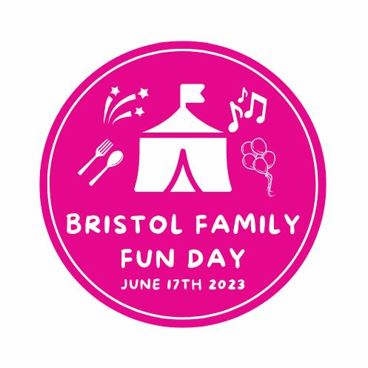

Community Sharing:
SR – An advocacy flier for early childhood has been redesigned by Jo Lopez. Donna K to send it out to BECA members and partners. BristolWorks began its Child Development Associate Credentials program with 26 participants and a waitlist.
Bristol Library – April vacation has lots of programming. The brochure for summer reading has been finalized and summer lunches will once again be offered at the library. http://www.bristollib.com/children/
Bristol Health – Staff and Parent education (birth, newborn and breastfeeding) is currently up and running. City of Bristol Parenting Expo is currently being designed.
UWWCC – Day of Caring, May 19th, reach out to Manny Martinez at mmartinez@uwwestcentralct.org or via phone at (860) 592-9559
BECC – The date for the One Night, One Purpose should be decided at an upcoming Administrative Meeting.
Parent Ambassador – Bristol SpareTime is offering free summer bowling to kids. Register by June 1st.
Bristol City Council – April 22nd is the City’s Annual Community Clean Up from 8:00 a.m. to 12:00 p.m. A few of the targeted neighborhoods, Riverside Avenue, No. Main/Main Street, etc. Provide your own gloves and other materials available at Bristol Park, Rec and Community Services (51 High St.) from 8:00-10:00 a.m.
Bristol Park & Rec… - Recently released summer program information. Next week an April vacation camp will be held. More information can be found on the website: Parks & Recreation | Bristol, CT - Official Website (bristolct.gov)
Next meeting: May 3, 2023 – IN PERSON!

